Subject: Strategic Transformation Project – Disney DTC

To: Board of Directors of Disney

From: Bob Iger, Chief Executive Officer

Date: 2024-03-14

Dear Esteemed Members of the Board,

In an increasingly competitive digital streaming landscape, Disney Direct-to-Consumer (DTC) is poised for a pivotal transformation. Embracing the mantra "The right board, the right strategy," we are poised to initiate a strategic transformation that meticulously addresses the competitive pressures from industry giants like Netflix and the rapidly evolving consumer expectations. Our transformation blueprint spans a five-year period, focusing on diversifying content offerings, leveraging digital technologies, and broadening our international footprint. This strategic overhaul aims not only to fortify Disney DTC's position as a leader in the global entertainment industry but is a resolute commitment to broaden our appeal and engagement with a more diverse global audience. By investing in innovative content, embracing new technological frontiers, and expanding our reach beyond traditional markets, we are committed to delivering unparalleled entertainment experiences. This executive summary encapsulates the essence of our ambitious journey towards sustaining Disney DTC's legacy, fostering growth, and enhancing shareholder value in the digital era.

**Overview of Disney DTC**

Disney, a titan of storytelling and innovation, has earned a storied legacy through our streaming services, including ESPN+, Disney+, and Hulu. Offering a vast library of over 500 films and 15,000 TV episodes, Disney has woven its magic into the fabric of the entertainment industry, as evidenced by its 22 Academy Nominations and substantial successes in 2023. Embracing the digital era, Disney melds time-honored storytelling with the latest digital trends, ensuring its offerings continue to captivate a global audience and adapt to their evolving preferences, thus maintaining our revered legacy in a rapidly changing market.

**Market Overview and Firm’s Position**

The streaming video market is burgeoning, projected to hit $697.2 billion by 2025-2030, with a 19.5% CAGR, propelled by tech advancements, the decline of traditional cable, and heightened demand for diverse, quality content accessible on demand. In this arena marked by intense competition and swift innovation, Disney+ stands out with 149 million subscribers. However, facing Netflix's market valuation of $258 billion against our $200 billion, and a subscriber dip from 161.8 to 149.6 million, Disney must refocus to maintain competitive edge. This competitive pressure accentuates the need for a focused strategy to bolster brand appeal and financial performance. Our $25 billion content investment signals a commitment to strategic recalibration that fortifies Disney DTC's position at the pinnacle of the entertainment sector, ensuring its cherished narrative endures amidst the industry's evolution.

**Primary Statement of Concern**

In the fiercely competitive streaming space, Disney DTC faces a pivotal challenge. Despite an upward ARPU trend within North America, Disney+’s subscriber base has contracted, starkly contrasted by Netflix’s climb to over 260 million subscribers by Q4 2023 (Appendix 1). Such trends compel a strategic reassessment to invigorate subscriber numbers and elevate ARPU, which trails Netflix’s $11.64 (Appendix 3). Moreover, our content investment per user is substantially higher than Netflix's (Appendix 4), necessitating a strategic optimization to bolster content efficiency and fulfill the audience's appetite for originality.

On the content and IP front, Disney's expenditure on four underperforming movies signals a need for a refreshed creative direction and the curation of new IPs, moving away from an over-reliance on franchises that risk audience fatigue (Appendix 2). This strategic balance aims to rejuvenate our portfolio, align with market expectations, and solidify Disney DTC's standing and fiscal vitality within the streaming landscape.

**Strategic Commitment and Framework**

As CEO, I am committed to steering Disney Direct-to-Consumer (DTC) toward unprecedented growth, efficiency, and a superior competitive stance. Our strategy emphasizes:

* **Market Transformation**: To capitalize on market dynamics and drive growth, we must target the pivotal 16-34 demographic, leveraging ESPN's robust digital presence to spur subscriber growth and revenue. This strategic move is essential to preserving the compelling nature of our sports content.
* **Product Transformation**: Revitalizing our content slate is key. Introducing innovative IPs while enriching our beloved franchises to stimulate fan engagement across diverse audiences, particularly the digital-native sector. Our strategy encompasses refining user experiences, tailored content for global audiences, adopting flexible pricing models, and tactically addressing the challenges of content saturation and price sensitivity with strategic finesse.
* **Digital Transformation**: Expanding ESPN's digital outreach and forging partnerships in gaming and AR/VR is a deliberate strategy to explore and unlock new revenue channels. This is pivotal for fostering enduring growth and ensuring long-term sustainability of our brand in the digital landscape.

**Transformation Objectives and Key Initiatives**

Our $25 billion yearly transformation plan is geared towards leveraging digital innovations, diversifying content, and broadening our global presence. We aim to:

* Enhance digital platforms for ESPN and Disney+ to boost subscriber engagement and growth.
* Develop a Content Hub powered by data analytics for strategic content creation based on consumer insights and market trends.
* Diversify our content portfolio through new IPs and strategic content acquisitions, aligning with audience preferences.
* Technologically advance by integrating AR/VR as well as collaborate with Epic Games for a new gaming product line, providing immersive entertainment experiences.
* Expand Hulu's international footprint and establish deep content creation partnerships to broaden Disney's global influence.

**Transformation Hypothesis**

Central to our approach is the Creativity Hub, aimed at fostering a balance between iconic franchises and innovative original content through demographic insights and data analytics. This initiative supports our commitment to content diversification and addresses market demands effectively.

We're embracing technological innovation by integrating augmented and virtual reality (AR/VR) and partnering with Epic Games to explore new gaming frontiers. These efforts are expected to deepen audience engagement and open new revenue avenues. Additionally, dynamic pricing strategies and tiered subscription models will be tailored to diverse consumer needs, enhancing our Average Revenue Per User (ARPU).

Our global expansion strategy, particularly for Hulu, aims to broaden our market presence and deliver localized content, reinforcing Disney's global brand appeal. By embedding Environmental, Social, and Governance (ESG) principles into our operations, we're positioning Disney DTC as a leader in responsible content creation. This transformative journey, overseen by the Streaming Strategy Committee, promises to solidify Disney's legacy in digital entertainment, ensuring long-term success and a global entertainment powerhouse.

**Key Transformation Project Indicators**

Our transformation's success will be measured against specific KPIs, focusing on:

* Profitability: Enhancing financial health through strategic initiatives.
* Content Investment Per User: Optimizing content spending to ensure maximum engagement and return on investment.
* Average Revenue Per User (ARPU): Elevating ARPU through innovative pricing models and subscriber growth strategies.

**Transformation Journey and Timeline**

Outlined over five years, our plan includes:

* Year 1: Cost optimization, Creativity Hub launch, exploration of international partnerships, and pricing model revisions.
* Years 2-3: Content production enhancement, deepening of digital partnerships, and global expansion.
* Years 4-5: Integration of ESG principles, achievement of sustainable growth, and solidification of market leadership through strategic pricing and subscription models.

**Resource Allocation**

Under my leadership, Disney Direct-to-Consumer (DTC) is setting a new course in our strategic investment, committing $25 billion annually towards our rich mix of content, with 40% dedicated to sports rights, including major deals through 2027, and 60% to entertainment. Notably, we are making a groundbreaking move with a $1.5 billion equity investment in Epic Games. This decision is pivotal, reflecting our ambition to blend Disney's storytelling legacy with the forefront of digital innovation and interactive entertainment.

This investment aligns with our vision to revolutionize the way we engage with audiences, combining Epic's expertise in immersive experiences with our storytelling prowess. It is a bold step towards integrating advanced gaming and virtual realities into our content ecosystem, enhancing our entertainment offerings and ensuring Disney remains a leader in a rapidly evolving digital landscape. This strategic direction is designed to foster growth, captivate global audiences, and sustain our market leadership, ensuring Disney's enduring legacy and success in the digital era.

**Change Management**

To navigate organizational changes effectively, Disney DTC implements a comprehensive strategy focusing on:

*Strategic Communication* to establish organization-wide alignment and commitment through clear and consistent messaging about the transformation's purpose, benefits, and progress. To maintain this communication:

* Quarterly townhall meetings will be held, incorporating team feeling reviews to assess and address the emotional and cultural impact of the transformation, ensuring every voice is heard and acknowledged.
* A monthly newsletter will keep all stakeholders informed about ongoing efforts, achievements, and upcoming initiatives, reinforcing the transformation's momentum and collective purpose.

*Organizational Development* equipping employees with the digital competencies necessary for the future. This includes:

* Tailored training and development programs launched to instill a culture of continuous learning and agility, ensuring the workforce is prepared for new challenges and opportunities.
* A capability and training plan review conducted semi-annually to evaluate the effectiveness of training initiatives, identify gaps, and adjust strategies accordingly to meet evolving needs.

*Stakeholder Engagement* emphasizing the importance of active involvement from employees, partners, and other stakeholders by:

* Regular updates and feedback sessions foster a participatory decision-making process, enhancing ownership and commitment to the transformation journey.
* Leveraging these interactions to minimize resistance, encourage open dialogue, and cultivate a supportive and inclusive environment for change.

By embedding these strategic components within the transformation program, Disney DTC aims to navigate the digital era with a workforce that is not only skilled and adaptable but also deeply engaged and aligned with the organization's evolving vision and goals.

**Risk Management and Mitigation** within Disney Direct-to-Consumer's (DTC) transformation is a multifaceted approach designed to proactively identify, assess, and address potential risks across operational, financial, technological, and market domains, ensuring the initiative's success and resilience.

* Operational Risks: To minimize disruptions and ensure a smooth transformation, Disney DTC will undertake comprehensive impact assessments and resource allocation reviews. A structured training and development program will be rolled out to bridge any skill gaps and ensure all employees are adept in navigating the new digital landscape. Regular process evaluations will help adapt and streamline operations in alignment with transformation goals.
* Financial Risks: Financial oversight will be rigorous, with a focus on adhering to the budget while achieving the $4.5 billion reduction target in content spending. Financial models will be regularly updated to reflect the transformation's impact accurately, ensuring fiscal health. Diversification of revenue streams and careful monitoring of expenses will mitigate risks of budget overruns or revenue loss during the transition.
* Technological Risks: In partnership with leading technology providers and leveraging the financial backing from strategic partnerships, such as with Apple Vision Pro, Disney DTC will ensure the highest standards of cybersecurity, data privacy, and system compatibility. Continuous technological updates and testing will prevent downtime and safeguard against data breaches, ensuring a seamless user experience.
* Market-Related Risks: Enhanced data analytics capabilities will enable constant monitoring of market trends, competitor actions, and consumer behavior, allowing Disney DTC to stay ahead in the competitive landscape. Advocacy for favorable regulatory reforms and strategic market positioning will address potential market risks.
* Organizational and External Stakeholder Risks: Through strategic communication, including quarterly town halls and monthly newsletters, and semi-annual capability and training plan reviews, Disney DTC will foster an inclusive environment that values employee and stakeholder input. This approach aims to boost confidence, ensure high motivation levels throughout the transformation, and build resilience against resistance to change.

**Governance Model**

The Streaming Strategy Committee plays a pivotal role in driving, monitoring, and ensuring the success of Disney Direct-to-Consumer's (DTC) transformation program (refer to Appendix 6 for committee details). Led by DTC Entertainment Leader Joe Earley, this team of senior executives brings strategic direction and operational excellence to the forefront of Disney's ambitious transformation efforts. This governance structure is instrumental in fostering agile decision-making, enabling the committee to respond swiftly to emerging challenges and opportunities.

Crucially, the committee oversees the comprehensive performance monitoring system, evaluating progress against key performance indicators (KPIs) such as subscriber growth, average revenue per user (ARPU), and content investment efficiency. These evaluations allow for real-time adjustments and strategic refinements, ensuring the transformation remains aligned with Disney's overarching objectives and the dynamic demands of the digital streaming market.

In managing change and mitigating risks, the committee implements a holistic approach. This includes developing and executing strategic communication plans to ensure clear messaging across the organization, spearheading organizational development initiatives to equip employees with necessary digital skills, and fostering stakeholder engagement to minimize resistance and build a culture of inclusivity and innovation.

By actively involving employees, partners, and other stakeholders in the transformation journey and addressing potential risks through proactive assessment and contingency planning, the committee aims to maintain a unified and motivated workforce throughout this period of significant change. Their leadership is key to navigating the transformation confidently, enhancing Disney DTC's competitive stance, and solidifying its leadership in the streaming industry in the digital era.

**Current Status of the Transformation Project**

Disney DTC is actively addressing the streaming market's dynamic challenges, showing promising trends in ARPU and moving towards profitability. However, a decline in subscriber numbers highlights the need for urgent action within our transformation plan for 2024 and 2025. Under the guidance of the Streaming Strategy Committee, led by Joe Earley, we are prioritizing:

* Market User Analysis Enhancement: Deepening our understanding of audience preferences to align our content strategy effectively.
* Creativity Hub Establishment: Implementing a venture-capital approach to content innovation, fostering data-driven creativity.
* Compensation Model Revision: Shifting towards performance-driven incentives to encourage innovation.
* Global Partnership Expansion: Strengthening international collaborations for localized content, enhancing Disney's global brand presence.

With Hulu now fully integrated, we are positioning Disney+ as the premier platform for family content, while Hulu targets older demographics, ensuring adaptability and market reach. Plans for Hulu include international expansion and content diversification to compete globally and produce resonant content.

These efforts are supported by 2024-2025 KPI targets (Appendix 5) aimed at boosting subscriber growth, optimizing content investment, and achieving long-term profitability.

**Conclusion and Next Steps**

Disney DTC transformation is not just a step towards innovation and market leadership; it represents a pivotal shift towards a future marked by foresight and groundbreaking innovation. Spearheaded by the Streaming Strategy Committee, our focused efforts are aimed at subscriber growth, optimizing content investment, and ensuring profitability. By enhancing market analysis, launching a Creativity Hub, revising compensation models, and expanding global partnerships, we are poised to redefine Disney DTC's role in the digital streaming landscape. This strategic realignment, underscored by specific Key Performance Indicator (KPI) targets, underscores our commitment to mastering the evolving entertainment market.

As we venture further, the importance of collaboration and strategic execution cannot be overstated. Our journey is fueled by a collective effort to navigate the challenges of the digital era, ensuring Disney DTC's legacy and success in the global entertainment industry. This transformation extends beyond mere adaptation; it is about cementing our place at the forefront of streaming and entertainment sectors. Through strategic investments in content diversification, state-of-the-art technology, and global expansion, we aim to elevate Disney+ to new heights, making it a symbol of innovation worldwide.

The role of the Board in this transformative journey is critical. Your leadership and guidance through the Steering Committee are integral to aligning our efforts with Disney's broader vision, while staying agile amidst the fast-evolving entertainment and technology landscape. Your governance acts as the compass that guides us, ensuring that our transformation resonates with employees, partners, and shareholders alike. By fostering transparent communication and collaborative engagement, and staying attuned to market trends and consumer preferences, we can refine our strategies to maintain our position as industry leaders.

I advocate for the Board's bold endorsement of our proposed $25 billion annual investment in this transformation. This isn't just a financial commitment; it's a visionary investment in our future, enabling us to lead in content diversification, technological advancements, and global presence. As we embrace this journey, we draw on the timeless values that define Disney, uniting to illuminate a future where our storied past meets the endless possibilities of the digital age. Together, let's build a legacy that reflects Disney's courage, creativity, and vision, captivating audiences worldwide for generations to come. This is the future we envisage, a testament to Disney's enduring spirit in an ever-changing world.

Warm regards,

Bob Iger

Chief Executive Officer

**Appendix**

**Appendix 1**

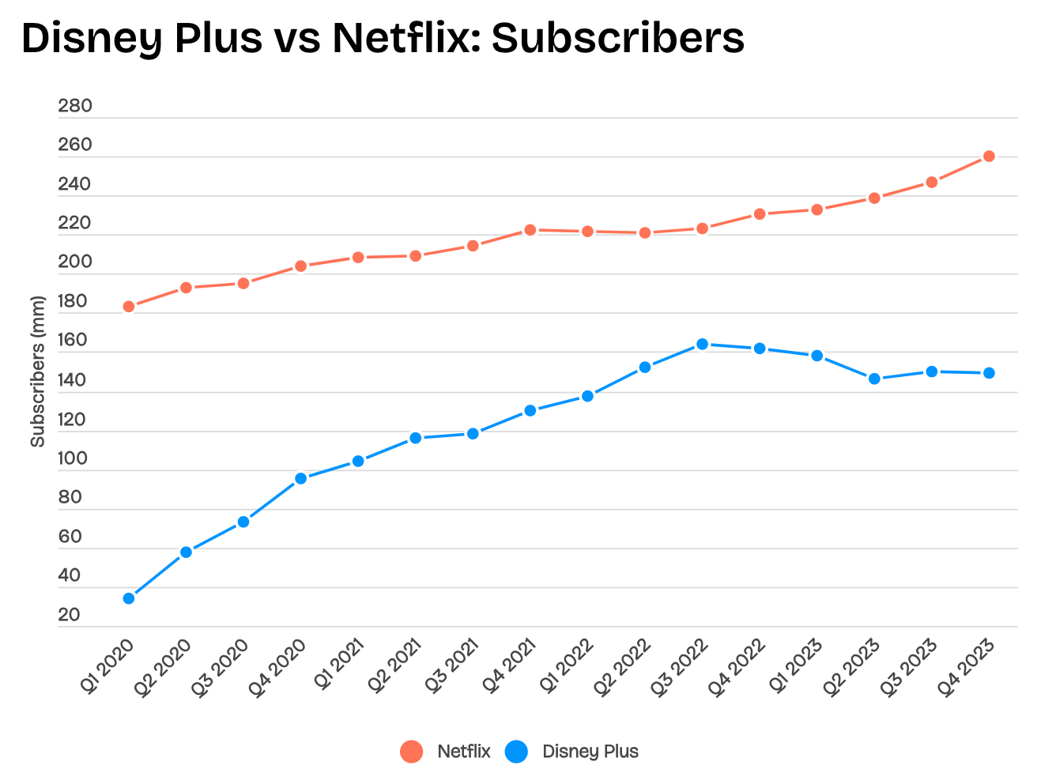

**Appendix 2**

|  |  |
| --- | --- |
| **Year** | **% of Original Content** |
| 2018 | 28% |
| 2019 | 55% |
| 2020 | 46% |
| 2021 | 50% |
| 2022 | 56% |
| 2023 | 56% |
| 2024 | 25% |

**Appendix 3**

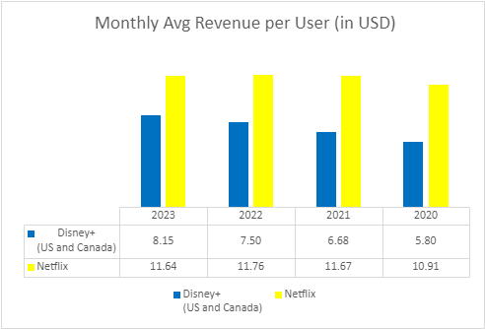

**Appendix 4**

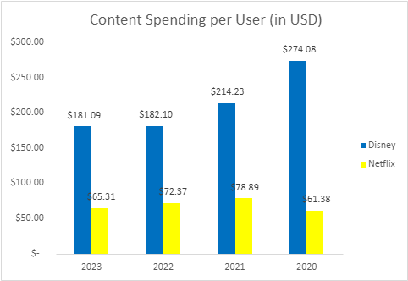

**Appendix 5 Disney DTC Transformation 2024-2025 Targets**

|  |  |  |  |  |
| --- | --- | --- | --- | --- |
| **Year / Quarter** | **Global Subscribers (in million)** | **Content Spending per User** | **Monthly ARPU**  **US and Canada** | **Profitability**  **(in million USD)** |
| 2024 Q1  (Oct-Dec 2023) | 149.6 | $181.09 | $8.15 | -$387 |
| 2024 Q2 | 182.2 | $152.25 | $8.95 | -$138 |
| 2024 Q3 | 200.0 | $138.89 | $9.50 | - |
| 2024 Q4 | 215.0 | $116.28 | $10.00 | $0 |
| 2025 Q1 | 225.8 | $97.45 | $10.50 | $300 |
| 2025 Q2 | 237.0 | $92.81 | $11.03 | $500 |
| 2025 Q3 | 250.0 | $88.00 | $11.64 | $500 |
| 2025 Q4 | 270.0 | $81.48 | $11.67 | $937 |

**Appendix 6 Streaming Strategy Committee**

The **committee members** responsible for steering this transformation include:

Robert Iger, CEO (Sponsor): Oversees the overall strategic direction and champions the transformation project across Disney DTC.

Joe Earley, DTC Entertainment (Leader): Directs the operational execution of the transformation plan, ensuring alignment with Disney's entertainment legacy.

Michael Paull, Direct to Consumer (Disney+, ESPN+, Hulu, and Star+): Focuses on the direct-to-consumer platforms, enhancing content delivery and subscriber experience.

Hugh F. Johnston, CFO: Manages financial oversight, ensuring the transformation is aligned with fiscal health and profitability goals.

Sean Corrigan, SVP of Corporate Strategy and Business Development: Leads strategic planning and market analysis to support the transformation objectives.

Rebecca Campbell, International Operations/Media & Hospitality/Transformation: Guides the global expansion and operational excellence in media and hospitality segments.

Jerrell Jimerson, Chief Product Officer, Disney Streaming & Direct-to-Consumer: Innovates product development and technology advancements across streaming platforms.

**Committee Responsibilities:**

* Performance Reviews: Our governance committee will conduct regular performance reviews, evaluating progress against key performance indicators (KPIs) such as subscriber growth, average revenue per user (ARPU), and content investment efficiency. These assessments are vital for ensuring that our transformation strategies remain aligned with our objectives and market demands, allowing for timely adjustments as necessary.
* Data Analysis: Leveraging advanced data analytics, the committee will gain deeper insights into subscriber behavior, content performance, and emerging market trends. This data-driven approach will inform strategic decisions, optimizing content investments and enhancing subscriber engagement.
* Stakeholder Feedback: Engaging with key stakeholders, including content creators, partners, and subscribers, is crucial for gathering feedback and insights. This engagement will inform the transformation's direction, ensuring that our strategies resonate with our audience and stakeholders' expectations.
* Technology Advancements: Staying at the forefront of technological advancements and digital trends is imperative. The committee will continually evaluate new technologies and digital platforms that can enhance the streaming experience, drive innovation, and potentially open up new revenue streams.
* Change Management:
* Strategic Communication: Crafting messaging that underscores the value and necessity of change, ensuring alignment across all levels of the organization.
* Organizational Development: Implementing training programs and leadership development to equip our team with the skills needed for the digital era.
* Stakeholder Engagement: Actively involving stakeholders in the transformation process to foster buy-in and mitigate resistance.
* Risk Mitigation Management:
* Proactive Risk Assessment: Identifying potential risks early in the transformation process, from content strategy shifts to technological implementations.
* Contingency Planning: Developing robust contingency plans to address potential disruptions and maintain business continuity.
* Regular Monitoring: Establishing a framework for ongoing risk evaluation and response, adapting strategies in real-time to mitigate risks effectively.
* Financial Oversight: Rigorous financial oversight will be maintained throughout the transformation process. Continuous monitoring of budget allocations, content spending, and profitability forecasts will be crucial for ensuring the financial sustainability of the transformation initiative. This oversight includes assessing the financial impact of strategic decisions and recalibrating financial models to align with our long-term goals.

**Monitoring actions include:**

Bi-weekly Executive Stand-up Meetings: These sessions provide a platform for quick reviews, updates, and alignment among the executive team, ensuring rapid decision-making and adaptation to emerging challenges or opportunities.

Monthly Follow-up Meetings: Conducted to assess progress against KPIs, discuss strategic adjustments, and delve deeper into operational aspects of the transformation. These meetings ensure sustained momentum and accountability.

Crisis Decision-making Protocol: In case KPIs deviate unfavorably for four consecutive weeks, this mechanism mandates immediate intervention. It allows the team to swiftly address issues, recalibrate strategies, and mitigate risks, ensuring the transformation remains on track.

**Appendix 7 DTC Transformation Plan**

|  |  |  |  |
| --- | --- | --- | --- |
| Year | Profitability | Content Investment Per User | Monthly ARPU |
| 1 | - Implement cost optimization strategies.  - Analyze and reduce non-essential expenses.  - Adjust compensation package, linking compensation to results.  - Initiate organizational change management (target capabilities mapping and investment) | - Invest in demographic analysis to refine content and user engagement.  - Creativity Hub (content strategies, investment validation)  - International content partnership studies and production trials. | - Revise pricing strategies.  - Introduce tiered subscription models.  - Implement targeted promotions and trials.  - International expansion of Hulu |
| 2 | - Focus on streamlining content production efficiency, quality and distribution. | - Expand partnerships with creators and influencers.  - Increase investment in data analytics for tailored content development. | - Enhance user experience and personalized content recommendations.  - ESPN APP spin off and available on other platforms.  - Boost international streaming partnerships |
| 3 | - Evaluate fiscal impact of new revenue streams and adjust strategies. | - Leverage analytics insights to refine content investment on high ROI genres/formats. | - Introduce AR/VR content experiences.  - Differentiate service to justify premium pricing tiers. |
| 4 | - Expand into new geographic markets with tailored strategies.  - Strengthen Disney's market position. | - Invest in technologies and storytelling for next-gen content experiences.  - Focus on genres and formats that offer the best ROI. | - Develop cross-platform bundles (streaming services, theme parks, merchandise)- Increase overall revenue per user. |
| 5 | - Focus on ESG principles in content production and corporate operations.  - Secure sustainable growth. | - Establish Disney as a leader in sustainable and socially responsible content creation.  - Enhance brand loyalty and attract a socially conscious audience. | - Optimize pricing and subscription models based on market analysis and user feedback.  - Ensure competitive positioning and user satisfaction. |

**References**

Disney Plus Revenue and Usage Statistics (2024)

<https://www.businessofapps.com/data/disney-plus-statistics/>



Netflix ARPU worldwide 2023

<https://www.statista.com/statistics/976588/netflix-monthly-streaming-revenue-per-customer/>

Netflix: content spend 2024 | Statista

<https://www.statista.com/statistics/964789/netflix-content-spend-worldwide/>

Content spending of Disney from fiscal years 2019 to 2024

<https://www.statista.com/statistics/1449640/content-spending-disney/#:~:text=In%20Disney%27s%20fiscal%202023%2C%20the,compared%20with%20the%20previous%20year>.

Supplemental-Information-for-Entertainment-Direct-to-Consumer

<https://view.officeapps.live.com/op/view.aspx?src=https%3A%2F%2Fthewaltdisneycompany.com%2Fapp%2Fuploads%2F2023%2F11%2FSupplemental-Information-for-Entertainment-Direct-to-Consumer.xlsx&wdOrigin=BROWSELINK>

[The 4 Flops Of 2023 That Cost Disney $1 Billion (forbes.com)](https://www.forbes.com/sites/carolinereid/2023/08/04/the-four-flops-of-2023-that-cost-disney-1-billion/)